# Sensing Acoustic signals

## Developing a solution

The minerals emit acoustic (ultrasound) signals, a sound wave at a frequency beyond the maximum frequency humans can hear. Sensors are readily available for detecting these signals and we initially decided to use the HC-SR04 as this was the first sensor that came to mind. However, we couldn’t use the sensor because Stott [1] stated the component was used for range-finding and not for continuous ultrasonic signals. The ultrasound receivers couldn’t be obtained at a reasonable price from the approved suppliers (see appendix 1), so we gambled on using the HC-SR04 sensor. We didn’t intend to use the whole sensor, but to extract the ultrasound receiver from it and determine if it was suitable for detecting the ultrasound signals emitted by the mineral. The receiver was extracted by desoldering it from the HC-SR04 sensor and to test if it worked, some wires had to be soldered to the leads so we could connect it to the breadboard.

Attaching the wires to a picoscope, we analysed the signal picked up by the receiver, a sinusoidal signal at 40 kHz and amplitude of around 10 mV. The signal needs to be amplified and coupled with an op-amp comparator to analyse the signal digitally. The signal amplification consisted of two non-inverting amplifiers with a gain of 40 each, resulting in a total gain of 1600.

*Fig. 1: Final circuit used to detect the acoustic signals emitted by the minerals, consisting of two non-inverting amplifiers.*

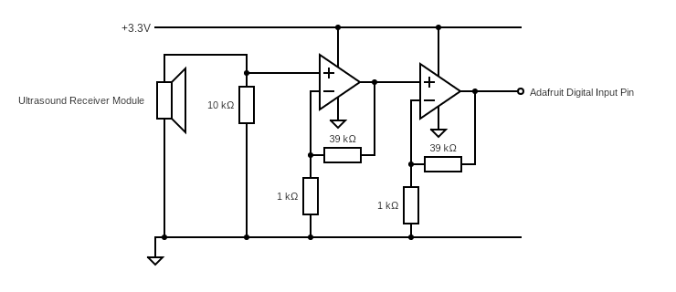

Placing the picoscope probe at the output for the amplification stage gave a waveform that similarly represents a square wave due to the amplifier clipping the signal at 3.3 V, the supply voltage for both op-amps.

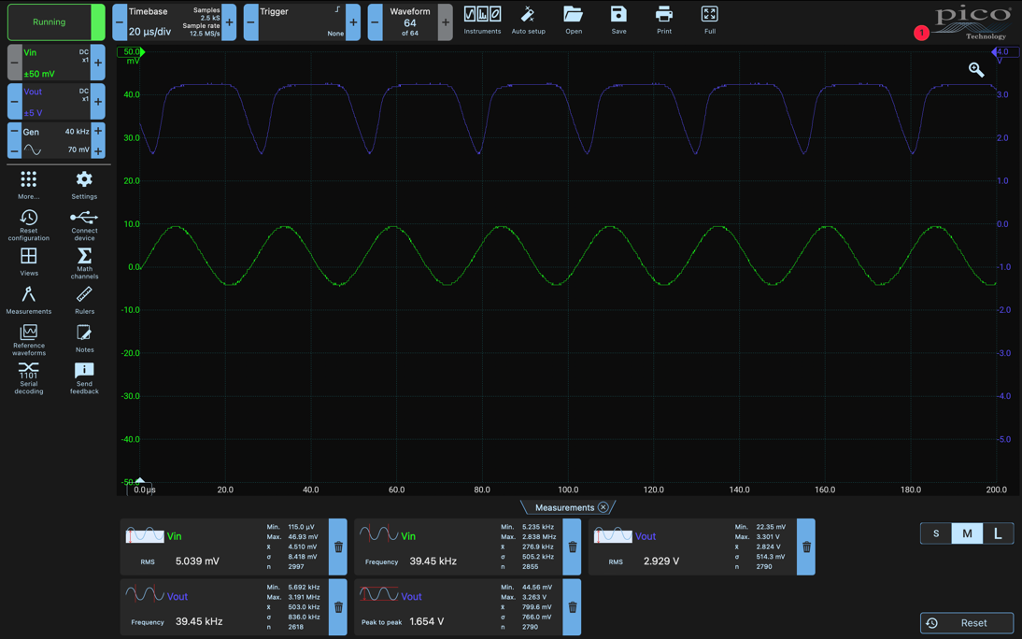

*Fig. 2: The Picoscope software showing the input sinusoidal waveform (green) and amplified output waveform (blue).*

The frequency of the output waveform in fig. 2 is 40 kHz, so there was a possibility of attaching the output for the amplifier to the digital pins on the Adafruit board since the signal was like a square wave. If this worked, we could exclude the op-amp comparator circuit to reduce the size and weight of the ultrasound sensing circuit. Despite being a sinusoidal signal, determining the frequency digitally was easier to implement than determining the frequency analogously, also we could use a similar code to the IR sensing circuit. We used the digital analysis code (see appendix 2) to output the frequency of our digital input signal if it was detected successfully.

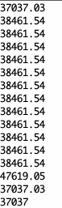

*Fig. 3: The Serial monitor software reporting the input “pulse” frequency for the code in appendix 2.*

Testing the input gave a surprising result, the code was able to determine the pulse frequency accurately (the frequency reported was around 40 kHz, which was what we were looking for). This confirmed our suspicion about analysing the signal without an op-amp comparator.

## Signal Analysis

The ultrasound signal can be analysed digitally as seen in fig. 3 so we can work out percentile values as the region of accepted values to provide accurate detection of the signal. However, filters were not implemented in the circuit schematic as high-frequency noise would still be detected amongst the high-frequency of the signal, also reducing the space and weight of the circuit. To determine the percentiles, we had to use a slightly different method than other signals; starting with copying the contents of the serial monitor into an excel spreadsheet. Then sort the data from smallest to largest and remove the values greater than 45000 and less than 36000. The 10th and 90th percentile values from the remaining data set were determined, with 37037.03 and 38461.54 being the 10th and 90th percentiles respectively. Using a similar code to analyse the IR pulses, we can detect the presence of the acoustic signal emitted by the mineral (see appendix 3).

When the ultrasound receiver is around 5 cm away from the top of the exorock, it successfully reports the detection of ultrasound signals.

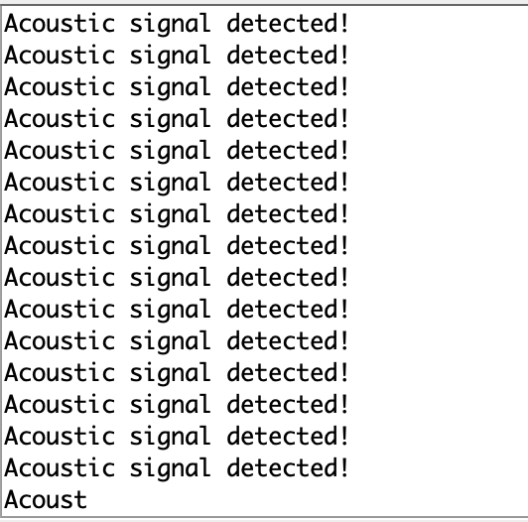

*Fig. 4: The circuit and code successfully detects acoustic signals*

## Evaluation:

Initially, we thought the hardest part of detecting this signal was analysing the code using an analogue pin since online forums have said measuring the frequency of a sinusoidal input was difficult and time-consuming, with many places recommending the use of an op-amp comparator circuit to convert the sinusoidal input to a digital input. However, we found out this wasn’t necessary due to the unexpected result from using 3.3V as the supply voltage for the amplification stage.

We also had difficulty obtaining a suitable ultrasound sensor at a low cost. We didn’t think about using the HC-SR04 until researching the component [2], then we thought about extracting an ultrasonic receiver and testing it seemed to work and we could finally move on with analysing the signal.

## Reference:

1. E. Stott. “Ultrasound sensor not responding #12”. edstem.org. <https://edstem.org/us/courses/22830/discussion/1547872> (accessed May 31, 2022)

2. Ultrasonic ranging module: HC-SR04, June 11, 2022. [Online]. Available: <https://www.electroschematics.com/wp-content/uploads/2013/07/HC-SR04-datasheet-version-2.pdf>

## Appendix:

1. Searching for a reasonably priced ultrasound receiver rated for 40 kHz was difficult from the approved suppliers. Several listings for ultrasound transducers from one supplier can be viewed here: <https://onecall.farnell.com/search?st=ultrasound%20transducer%2040%20khz&ICID=I-RS-STM7REC-4>. We thought we could obtain an ultrasound receiver at a cheaper price since £4 was slightly too expensive for a receiver.

2. We are reusing the same code used to determine the infrared pulse frequency. All functionalities should be the same but with output lines in the if statement not being appropriate to the ultrasound signal. The code can be found here: <https://github.com/shekratul10/EEProject/blob/main/Sensor/IR%20Pulse/code/IR_digital_test1.ino>.

3. The code to determine the presence of an acoustic signal at 40 kHz can be found here: <https://github.com/shekratul10/EEProject/blob/main/Sensor/Ultrasound/ultrasound_analysis.ino>.